Current Activities & Acquisitions

Electromatic Typewriter

Our Electromatic typewriter has arrived. On inspection we believe this model may have been built between 1933, when Electromatic was acquired by IBM and 1935, when IBM's redesigned version was released. Investigations continue.
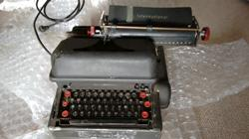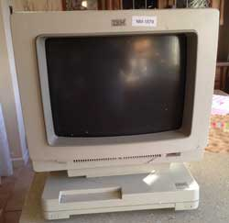

3179
We have also now obtained the 3179 colour display terminal mentioned in the previous report. Unfortunately it was damaged in transit, showing signs of being dropped from a great height. The monitor case is cracked in a number of places, but the machine appears to still be functional. This is a Model 2, which was specifically designed for connection to AS/400 and related mid-range systems.

The only positive is that we obtained a full refund from eBay for the shipping costs plus half the cost of the machine.

New Display Items
We have moved a large AS/400 plus expansion unit and tape library out to the display area. Space was created by installing two tier shelving for the typewriter collection. The back office area where these machines were kept has now been updated with racking to provide more storage.
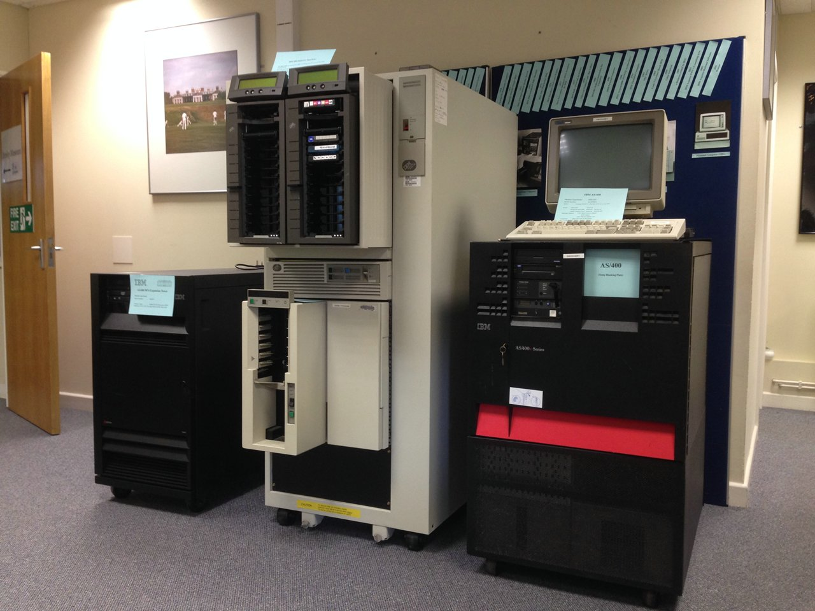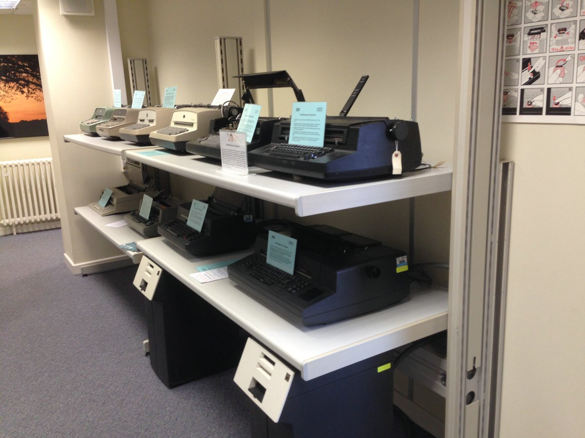

CashPoint Model
The model of the 2984 Lloyds CashPoint continues slowly. We have a full set of keytops printed on a 3D printer and finished off with vinyl transfers, and the keyboard & dispensing enclosure is partly built.
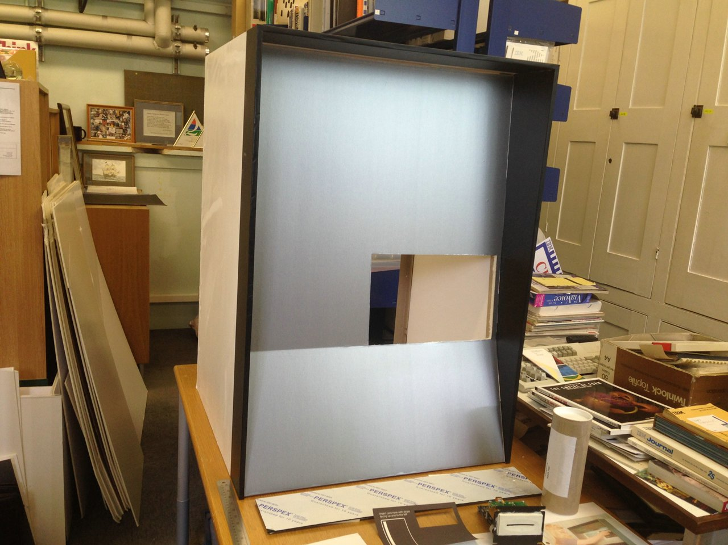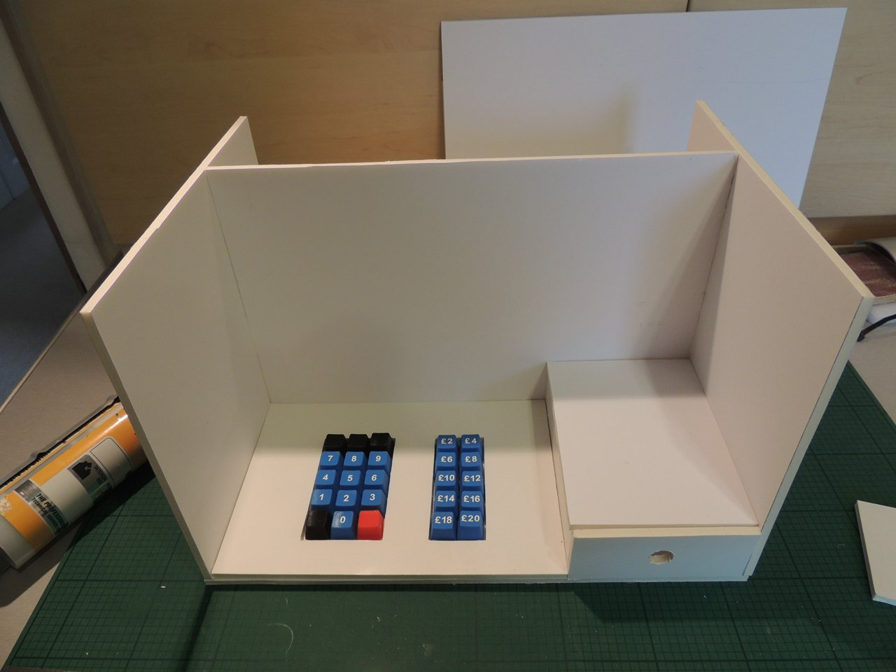

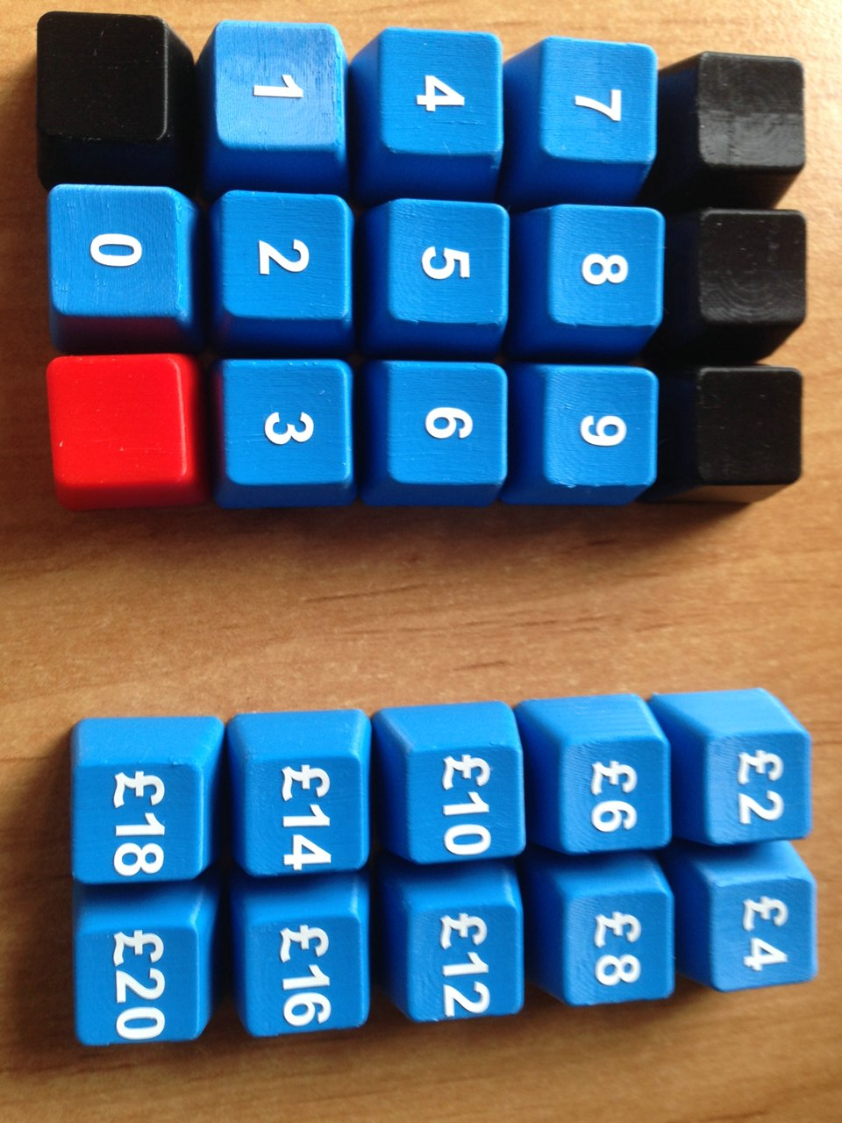

Other
We’ve moved a small display cabinet, made redundant after installing the new cabinets earlier this year, into the lower ground floor corridor.

The web site panorama images have been updated to show the modified display areas.

Loans to Other Organisations
A lesson in managing loans to other organisations. Some years ago the museum loaned a number of artefacts to an organisation in Winchester aimed at teaching children about technology. This was somewhat before my time, and the loan agreement was not followed up annually as it should have been, until we discovered it in the files last year. We requested return of our artefacts after we learned that two items had gone missing.

In spite of a comprehensive search the missing items have not been located and we must assume lost. We are always willing to lend out items but in future we will need to inspect the security measures at the display location and carry out regular checks.

